**Assignment 4**

**SMS SPAM Classification**

|  |  |
| --- | --- |
| Assignment Date | 30 October 2022 |
| Student Name | Harenee A S |
| Student Roll Number | 2019PITIT116 |
| Maximum Marks | 2 Marks |

1. Import Required Libraries

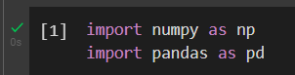

1. Read Dataset Do Pre-processing

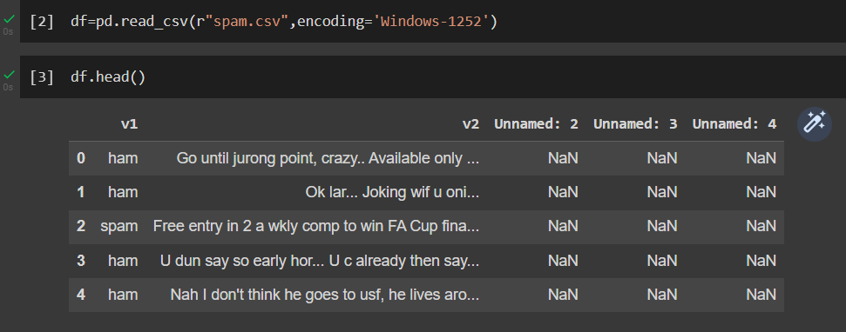

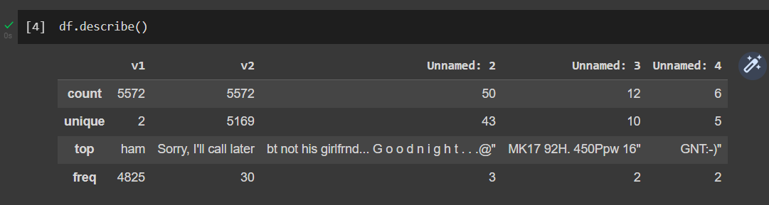

1. Create Model

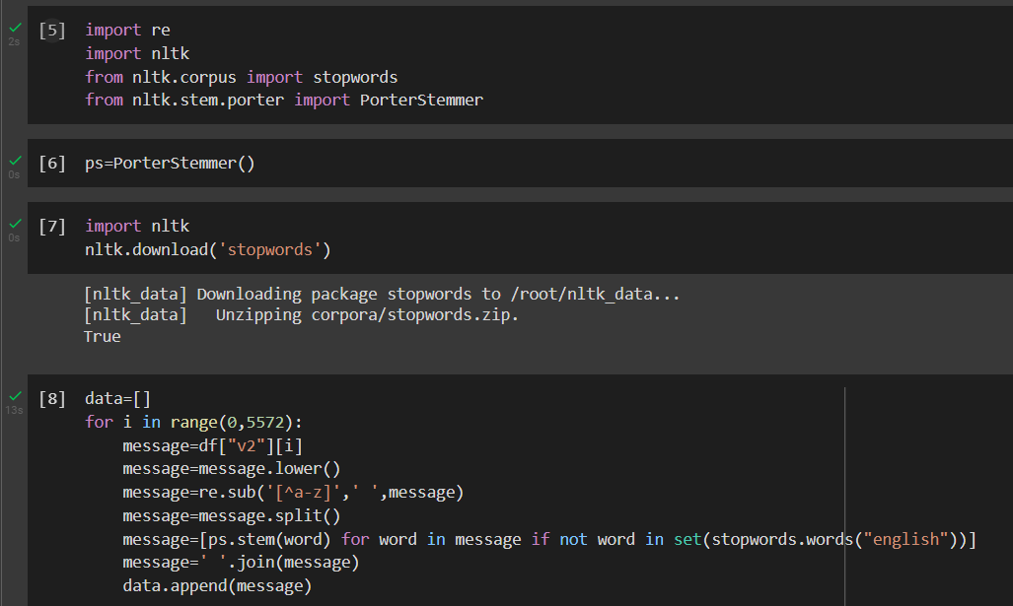

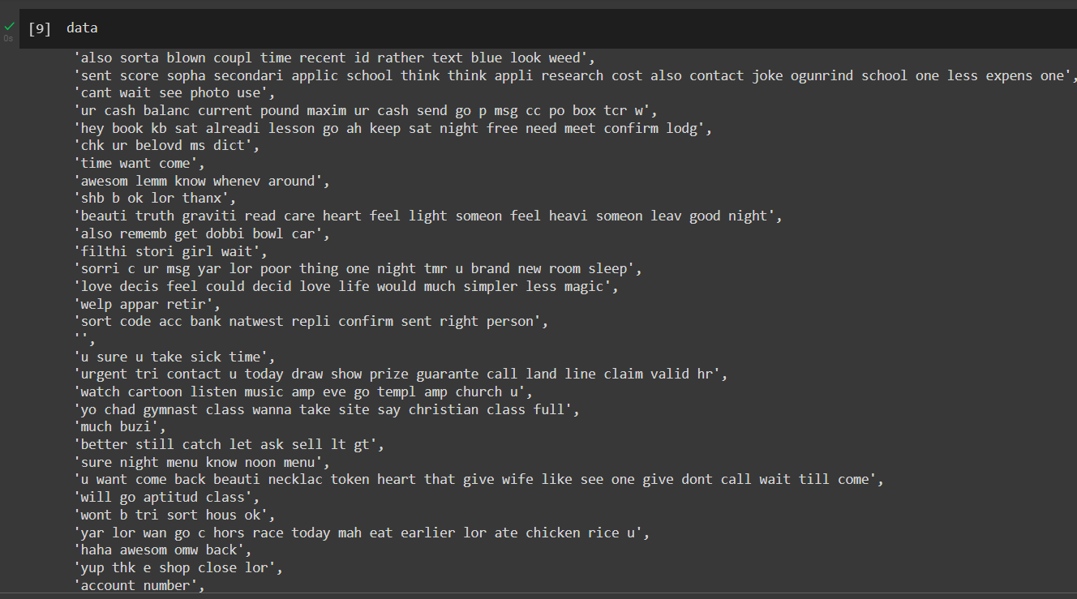

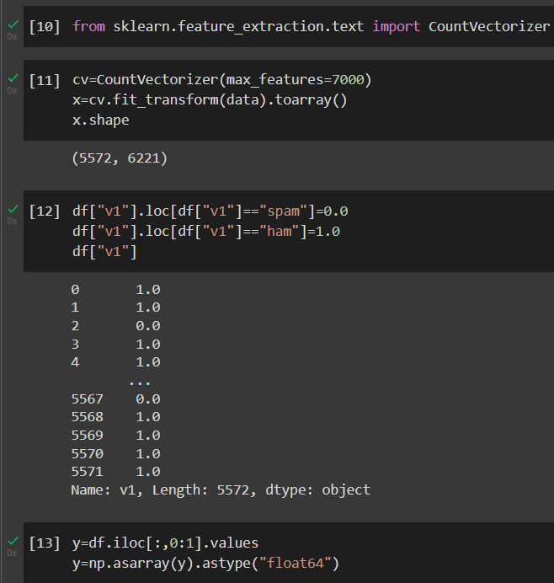

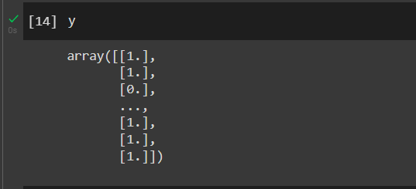

1. Add Layers

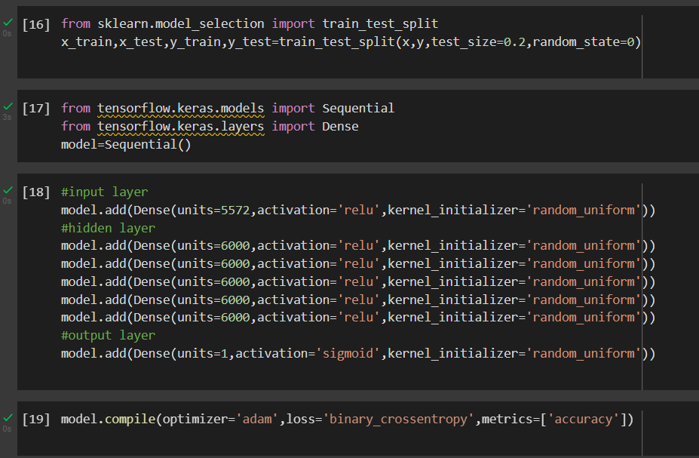

1. Compile the model



1. Fit the Model

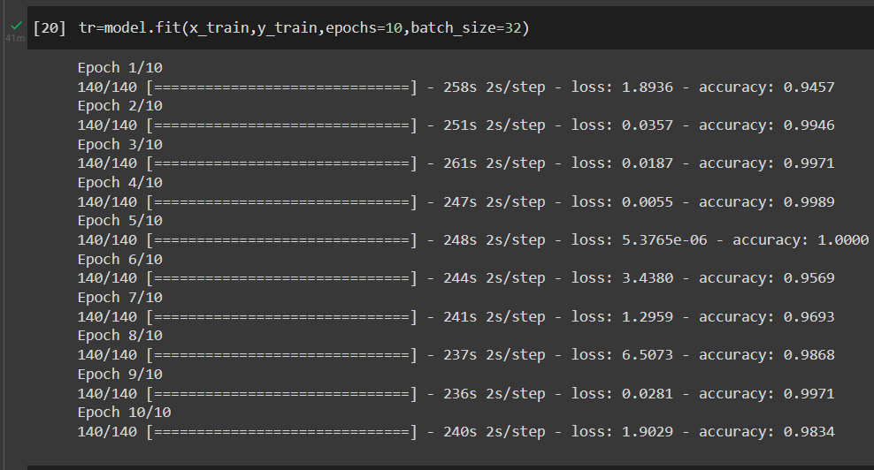

1. Save the Model

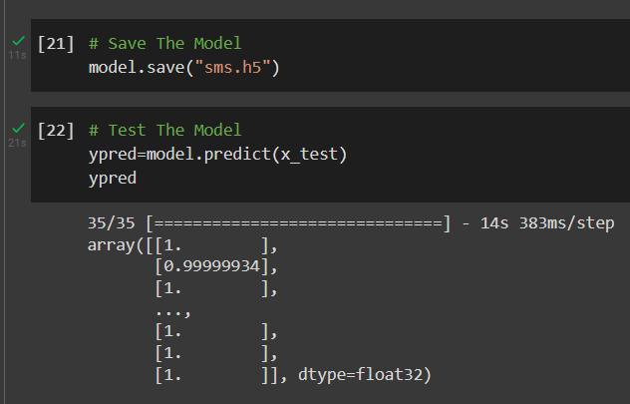

1. Test the Model

